1.

lag_flash = [1, 2, 3, 4, 5]

            signal[t_flash[i,0]-lag:t_flash[i,0]+250-lag,:] += (erptemplate1*3)

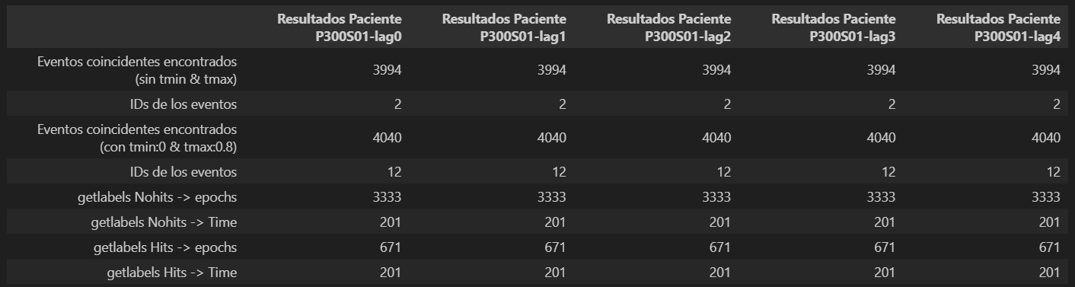

2.

lag_flash = [1, 2, 3, 4, 5]

            signal[t_flash[i,0]-lag:t_flash[i,0]+250-lag,:] += (erptemplate1*lag)

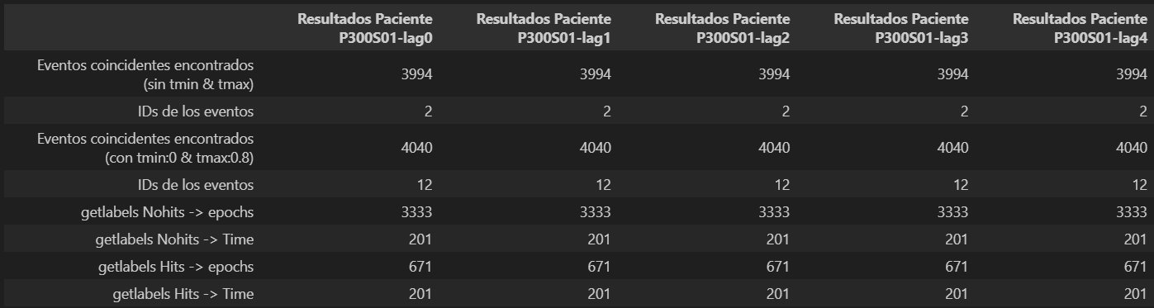

3. Sin DrugSignal, desde el archivo de Rodrigo.

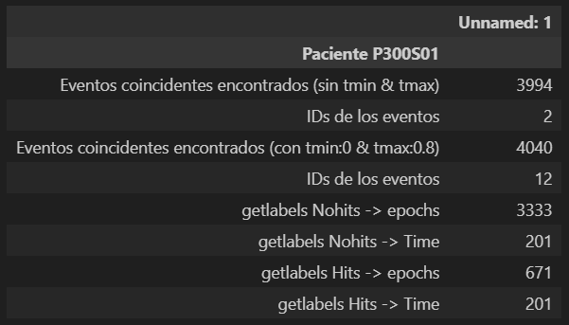

4040 events found

Event IDs: [ 1 2 3 4 5 6 7 8 9 10 11 12]

Not setting metadata

4040 matching events found

No baseline correction applied

Using data from preloaded Raw for 4040 events and 201 original time points ...

0 bad epochs dropped

4004 events found

Event IDs: [1 2]

Not setting metadata

3333 matching events found

No baseline correction applied

Using data from preloaded Raw for 3333 events and 201 original time points ...

0 bad epochs dropped

4004 events found

Event IDs: [1 2]

Not setting metadata

671 matching events found

No baseline correction applied

Using data from preloaded Raw for 671 events and 201 original time points ...

0 bad epochs dropped

4004 events found

Event IDs: [1 2]

Not setting metadata

4004 matching events found

No baseline correction applied

Using data from preloaded Raw for 4004 events and 201 original time points ...

0 bad epochs dropped

4. Con DrugSignal, desde el archivo de Rodrigo.

signal[t_flash[i,0]-1:t_flash[i,0]+250-1,:] += (erptemplate1*3)

Drogo la señal y no pasa nada. Idéntico al punto 3.

5. Con DrugSignal, desde el archivo de Rodrigo.

signal[t_flash[i,0]-2:t_flash[i,0]+250-2,:] += (erptemplate1*3)

Drogo la señal y no pasa nada. Idéntico al punto 3.

precision recall f1-score support

**nohit 0.85 0.99 0.91 1000**

**hit 0.71 0.12 0.21 204**

accuracy 0.84 1204

macro avg 0.78 0.56 0.56 1204

weighted avg 0.82 0.84 0.79 1204

[[990 10]

[179 25]]

[[0.99 0.01 ]

[0.87745098 0.12254902]]

0.8430232558139535

precision recall f1-score support

**nohit 0.91 0.96 0.94 1000**

**hit 0.75 0.52 0.62 204**

accuracy 0.89 1204

macro avg 0.83 0.74 0.78 1204

weighted avg 0.88 0.89 0.88 1204

[[965 35]

[ 97 107]]

[[0.965 0.035 ]

[0.4754902 0.5245098]]

0.8903654485049833

precision recall f1-score support

**nohit 0.96 0.97 0.97 1000**

**hit 0.86 0.81 0.84 204**

accuracy 0.95 1204

macro avg 0.91 0.89 0.90 1204

weighted avg 0.95 0.95 0.95 1204

[[974 26]

[ 38 166]]

[[0.974 0.026 ]

[0.18627451 0.81372549]]

0.946843853820598

c:\Users\alexc\anaconda3\lib\site-packages\sklearn\linear_model\_logistic.py:763: ConvergenceWarning: lbfgs failed to converge (status=1):

STOP: TOTAL NO. of ITERATIONS REACHED LIMIT.